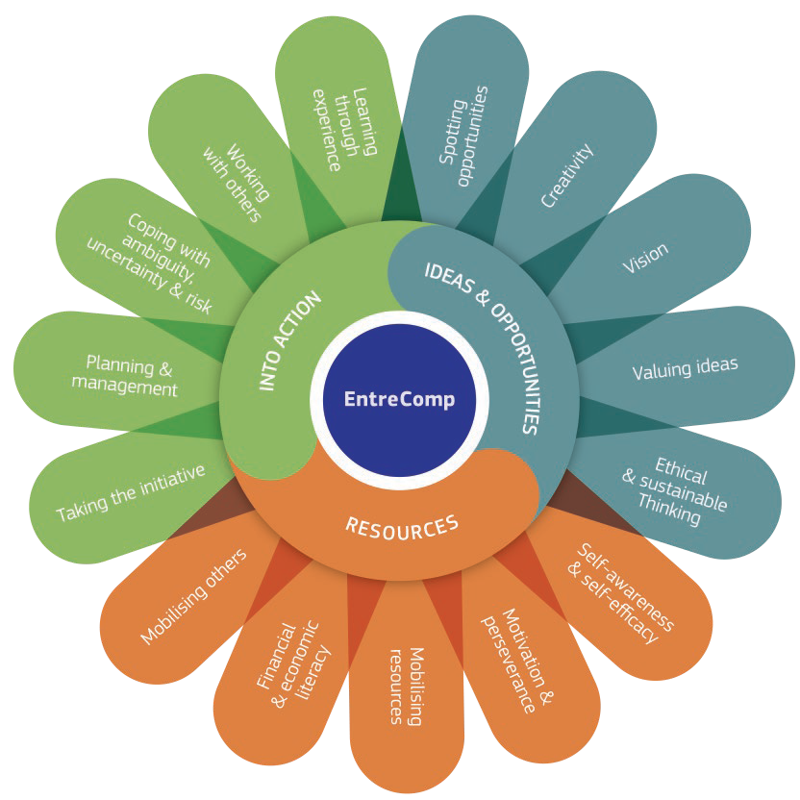

EntreComp
The European Entrepreneurship Competence Framework
COMPETENCE | HINT | DESCRIPTION | NOTES
1.1  Spotting opportunities | Use your imagination and abilities to identify opportunities for creating value | - Identify and seize opportunities to create value by exploring the social, cultural and economic landscape  - Identify needs and challenges that need to be met  - Establish new connections and bring together scattered elements of the landscape to create opportunities to create value
1.2  Creativity | Develop creative and purposeful ideas | - Develop several ideas and opportunities to create value, including better solutions to existing and new challenges  - Explore and experiment with innovative approaches  - Combine knowledge and resources to achieve valuable eﬀects
1.3  Vision | Work towards your vision of the future | - Imagine the future  - Develop a vision to turn ideas into action  - Visualise future scenarios to help guide eﬀort and action
1.4  Valuing ideas | Make the most of ideas and opportunities | - Judge what value is in social, cultural and economic terms  - Recognise the potential an idea has for creating value and identify suitable ways of making the most out of it
1.5  Ethical & sustainable thinking | Assess the consequences and impact of ideas, opportunities and actions | - Assess the consequences of ideas that bring value and the eﬀect of entrepreneurial action on the target community, the market, society and the environment  - Reflect on how sustainable long-term social, cultural and economic goals are, and the course of action chosen  - Act responsibly

IDEAS & OPPORTUNITIES

COMPETENCE | HINT | DESCRIPTION | NOTES
2.1  Self-awareness & self-eﬃcacy | Believe in yourself and keep developing | - Reflect on your needs, aspirations and wants in the short, medium and long term  - Identify and assess your individual and group strengths and weaknesses  - Believe in your ability to influence the course of events, despite uncertainty, setbacks and temporary failures
2.2  Motivation & perseverance | Stay focused and don’t give up | - Be determined to turn ideas into action and satisfy your need to achieve  - Be prepared to be patient and keep trying to achieve your long-term individual or group aims  - Be resilient under pressure, adversity, and temporary failure
2.3  Mobilising resources | Gather and manage the resources you need | - Get and manage the material, non-material and digital resources needed to turn ideas into action  - Make the most of limited resources  - Get and manage the competences needed at any stage, including technical, legal, tax and digital competences
2.4  Financial & economic literacy | Develop financial and economic know-how | - Estimate the cost of turning an idea into a value-creating activity  - Plan, put in place and evaluate financial decisions over time  - Manage financing to make sure your value-creating activity can last over the long term
2.5  Mobilising others | Inspire, enthuse and get others on board | - Inspire and enthuse relevant stakeholders  - Get the support needed to achieve valuable outcomes  - Demonstrate eﬀective communication, persuasion, negotiation and leadership
INTO ACTION
RESOURCES
COMPETENCE | HINT | DESCRIPTION | NOTES
3.1  Taking the initiative | Go for it | - Initiate processes that create value  - Take up challenges  - Act and work independently to achieve goals, stick to intentions and carry out planned tasks
3.2  Planning & management | Prioritise, organise and follow up | - Set long-, medium- and short-term goals  - Define priorities and action plans  - Adapt to unforeseen changes
3.3  Coping with uncertainty, ambiguity & risk | Make decisions dealing with uncertainty, ambiguity and risk | - Make decisions when the result of that decision is uncertain, when the information available is partial or ambiguous, or when there is a risk of unintended outcomes  - Within the value-creating process, include structured ways of testing ideas and prototypes from the early stages, to reduce risks of failing  - Handle fast-moving situations promptly and flexibly
3.4  Working with others | Team up, collaborate and network | - Work together and co-operate with others to develop ideas and turn them into action  - Network  - Solve conflicts and face up to competition positively when necessary
3.5  Learning through experience | Learn by doing | - Use any initiative for value creation as a learning opportunity  - Learn with others, including peers and mentors  - Reflect and learn from both success and failure (your own and other people’s)

